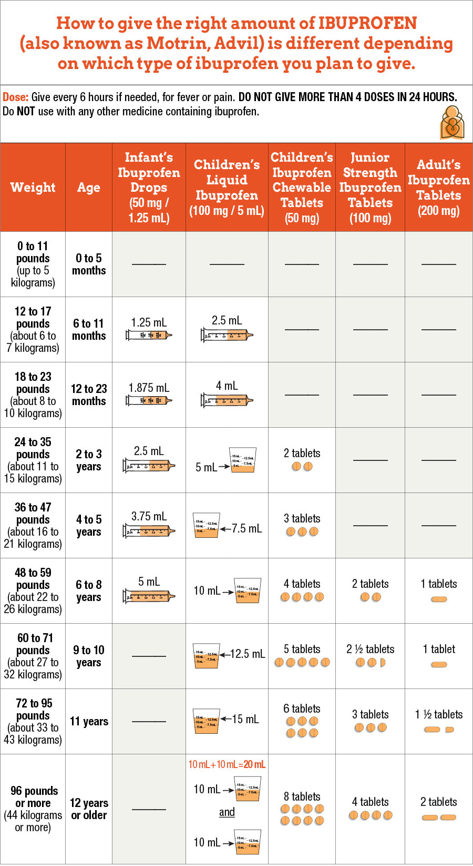
- Age of child: Do not use ibuprofen in children who are less than 6 months old unless your child's doctor tells you to. This is because it has not been found to be safe in children less than 6 months old. The use of the medicine in children less than 6 months is also not approved by the FDA. It is also best not to give medicines with more than one ingredient in it to children less than 6 years of age.
- Dosage: Determine by finding child's weight in the top row of the dosage table.
- Measuring the dose for liquid medicines (should be in "mL" or metric units): It is easier to give the right amount of liquid medicine when using a syringe than when using a kitchen teaspoon or tablespoon. Use the syringe or dosing cup that comes with the medicine. If a tool does not come with the medicine, ask your pharmacist for one.
- Ibuprofen drops: Ibuprofen infant drops come with a measuring syringe.
- Adult dosage: 400 mg
- How often to give the medicine (frequency): You can give ibuprofen every 6-8 hours if needed.

