2401 Research Blvd. #370
Rockville, MD 20850
(301) 990-1664

10301 Georgia Ave. #106
Silver Spring, MD 20902
(301-681-6000

TICK BITES
Now that summer is officially here, more children will be spending time outdoors camping, hiking, and playing. While summer may mean more outdoor activities and opportunities to enjoy Mother Nature, it’s also the time of year when our office gets many phone calls and office visits from concerned parents about ticks and tick bites.
Below is some insight about what to do if you get a tick bite, which ticks you should be concerned about, and what to do after you’ve had a tick bite.
While many parents are rightfully concerned after their children have a tick bite, the risk of acquiring a tick related illness—such as Lyme disease—is quite low. In fact, the risk of acquiring Lyme disease after a tick bite is below 2 % even in areas where the disease is common.
For ticks to transmit an infection a series of events must occur: (1) they have to attach to the child, (2) take their first blood meal and then (3) become engorged (meaning full of your blood).
Many people think ticks are only present in the woods. However, ticks can be found in many areas.
- Where woods/fields meet lawn
- Wooded areas
- Tall brush/grass
- Under leaves*
- Very small numbers on cut/raked lawns or sports fields
- Under ground cover (plants) in yard *
- Around stone walls and woodpiles where mice & other small mammals live
*under plants/leaves to prevent dehydration

I got a tick, now what do I do?
The following graphic shows how to remove a tick the right way:
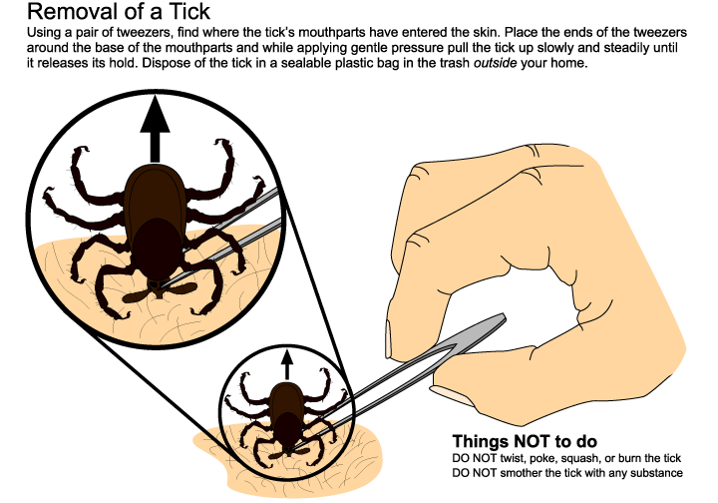

If part of the tick’s head remains embedded in the skin, do not try to remove it. Your body will eventually expel it.
It is helpful to identify the type of tick especially if it is an engorged deer tick since they can transmit Lyme disease. The other ticks and conditions mentioned below are less common in this region. The picture below shows the most common types of ticks:
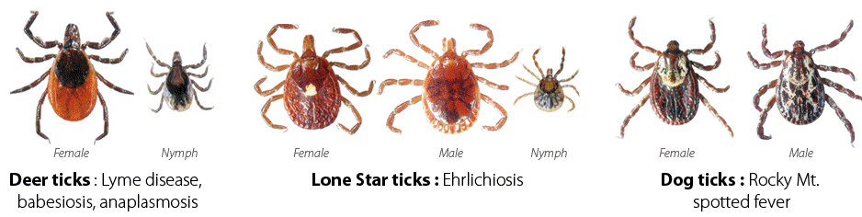

What are signs of tick related infections?
- Rash that develops days or weeks after the bite. A red bump encircled by a red rash or bulls’ eye rash is a typical feature of the early stage of Lyme disease. Dark blue or purple dots on wrists and ankles can be a sign of Rocky Mt. spotted fever.
- Flu like symptoms such as fever, headache, body aches, joint pain, fever, fatigue can be a sign of infection.

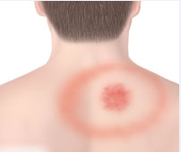
Bull’s eye rash

How to prevent tick bites?
- Conduct a full body check upon return from tick infested areas. Check your children for ticks under the arms, in and around the ears, inside the belly button, behind the knees, between the legs, around the waist, and especially in their hair.
- Examine clothes and gear. Ticks can come into the home on clothing, then attach to a person later, so carefully examine coats, and backpacks. Tumbling clothes in a dryer on the highest heat for at least one hour may help kill remaining ticks.
- Repellents containing 20-30% or more DEET (N, N-diethyl-m-toluamide) can be applied to the skin, and they can protect up to several hours. These repellents should not be used in children under 2 years of age or near the mouth or hands.

