2401 Research Blvd. #370, Rockville, MD 20850
(301) 990-1664
10301 Georgia Ave. #106, Silver spring, MD 20902
(301)681-6000
www.childrenfirstpediatrics.com

What is a Concussion?

ncussion?

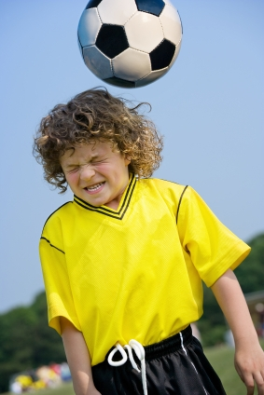
A concussion is a brain injury that causes an alteration in its function. It can happen after a direct blow to the head (even while wearing a helmet) or through any other accident that causes the brain to move violently back and forth within the skull. An example of this could be during a car accident where the person does not hit the dashboard. Since this is a dysfunctional problem of the brain, a concussion cannot be seen on x-rays or CT scan.
What are the symptoms and signs of concussion?
It is important to know that the individual does not need to be “knocked out” (lose consciousness) to have had a concussion. In fact, fewer than 10% of sports related concussions present with loss of consciousness. There are 4 groups of symptoms that can develop after a concussion:
- Cognitive or thinking problems
• Difficulty remembering or concentrating: May not know time, date, place, details of their circumstance. Cannot remember things that happened before or after the injury
• General confusion or mental fog
• Feeling lethargic or disoriented
- Physical symptoms
• Headache
• Dizziness and balance problems
• Vomiting/nausea
• Light sensitivity, muffled hearing or ringing in the ears
- Emotional symptoms
• Irritability, Nervousness
• Sadness or feeling more emotional
- Sleep disturbance
• Difficulty falling asleep
• Sleeping more or less than usual
• Drowsiness
What should you do if your child or adolescent gets a concussion?
The individual should stop activity right away. If a loss of consciousness (“knocked out”) has occurred, it is critical to call an ambulance to take him/her to a hospital.

It is vital not to move the individual until the paramedics arrive if an injury to the neck is suspected.
How is it treated?
The most important part of the treatment is sleep, and resting physically and mentally.
The individual should avoid activities that might cause another head injury or trigger concussion symptoms.
It is very important to avoid late nights, texting, exposure to screen, videogames or lengthy activities that require prolonged concentration such as homework or studying for exams.
Once the individual is completely better at rest (free of concussion symptoms), he/she can start a step-wise increase in activities that your doctor and teacher/coach will determine.
How long will it take to get better?
Everybody recovers differently from a concussion. In most cases, signs and symptoms last approximately 7-10 days, but in some cases, it can take several weeks or months for a full recovery. Having a history of previous concussions and not resting can significantly prolong the recovery time.
When should you see the doctor?
Every person who gets a head injury should be seen by a doctor, ideally within 48 hours from the injury. The following are conditions that warrant immediate attention:
1. Increased confusion
2. Worsening headache:
3. Vomiting
4. Difficulty awakening
5. Trouble walking
6. Experiencing seizures
7. Exhibiting strange behavior

At Children First Pediatrics, we have started offering a sophisticated computer based cognitive test (ImPACT) to help doctors track recovery and make decisions regarding academic needs following a concussion. This is being offered to any child in the community and not just for Children First Patients. Call us to inquire about a baseline test if your child is or will be participating in activities that pose a risk for concussion.

